**Computer Networks (CN-307)**

**Project Final-Evaluation Report**

**Project Title:**

Multi-User Messenger App with Multi-Media Messaging

**Project Submitted to:**

Prof. Dr. Fahad Samad

**Project Submitted by:**

Khizer Mehmood (K16-3731) Sec: C

**Introduction of Project:**

The motive to build this project is to develop a simple multi-user messenger application in Java using socket programming. Socket programming will allow to communicate two or more computers over the network using TCP and FTP protocols. Tools which are to be used in this project are, Java language, Netbeans, JavaFX/JSwing (a standard GUI library for Java).

**Features and Scope of the Project:**

* This application will provide single-client server messaging.
* This application will provide multi-client server messaging (group messaging).
* Users can send messages in simple textual form.
* Users can send messages in multimedia form i.e. files, images etc.
* Users can check the presence of other users present on the server.
* The scope of this project will be a desktop application with an intuitive GUI.

**Design of the Project:**

In client/server application we first need to setup a server before a client which will keep listening to the client for connection. For a successful connection a client must know an assigned IP address and port number of the server, then after the establishment of connection both server and client applications can send or receive messages.

Following order of the components will be followed to design this application:

* Server Socket Development
* Client Presence Detection
* Single and Group Messaging
* Chat Client API Development
* Application GUI Development

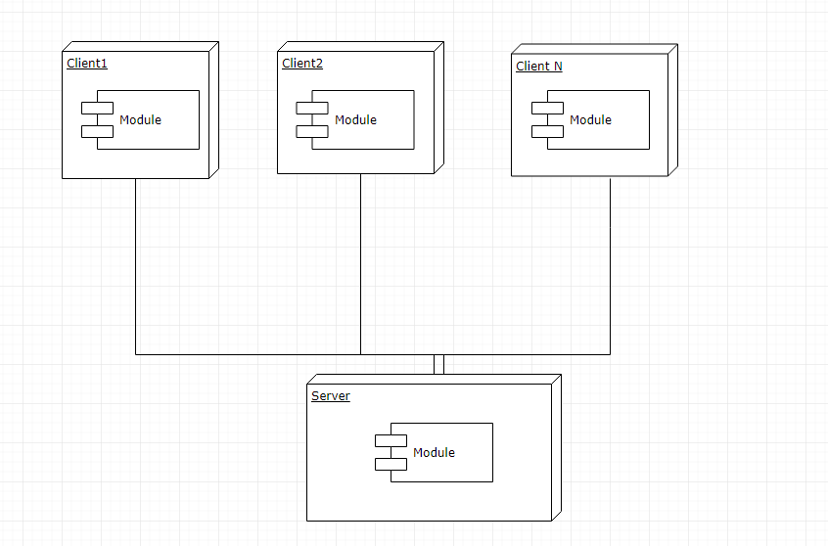

**Description of Modules:**

Following is the description of modules that are developed, and a separate file for source code is attached with the document:

* Server Socket Development :

In this application client server architecture is implemented, the server side code is completed, a server is always listening for clients to make TCP connection using ServerSocket API provided by Java, for multiple clients to make connections with single server the concept of multi-threading is used.

* Client Presence Detection:

Once a TCP connection is established with a client, server sets a flag for that client to be activated and shows that client’s status to other clients as online. If the receiver client is already connected then server immediately transfers the sender’s message to receiver otherwise it will transfer that message when receiver gets connected with server.

* Single and Group Messaging:

In single messaging the concept of direct communication is implemented, this is one to one private chat after the establishment of connection of both users with server. In group messaging the concept of chat-room is implemented, each user who wants to get connected to a particular chat room must join the ‘topic’ and each user can also leave chat-room at any time.

* Chat Client API Development:

After the completion of Server API development then client API is developed. In client API all the methods including handledMessaging(), handlePresenceDetection(), handleFileTransfer(), handleLogin(), handleLogout() etc and various interfaces and listeners are developed.